Tactical Monsters Rumble Arena

Clicker

# Configuration

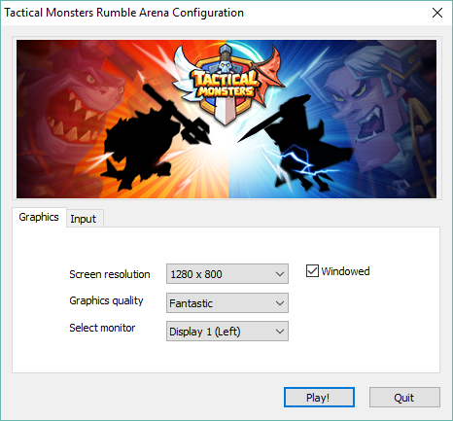

When run the game, please use following settings:

* Screen resolution – 1280 x 800
* Mode – Windowed (checked)
* Other parameters are not critical for the clicker works.

Current version of the clicker is limited to support one resolution only. It’s possible to extend current version by getting more images and add small part of logic.

# Play

When the game has loaded, click on Rumble button.

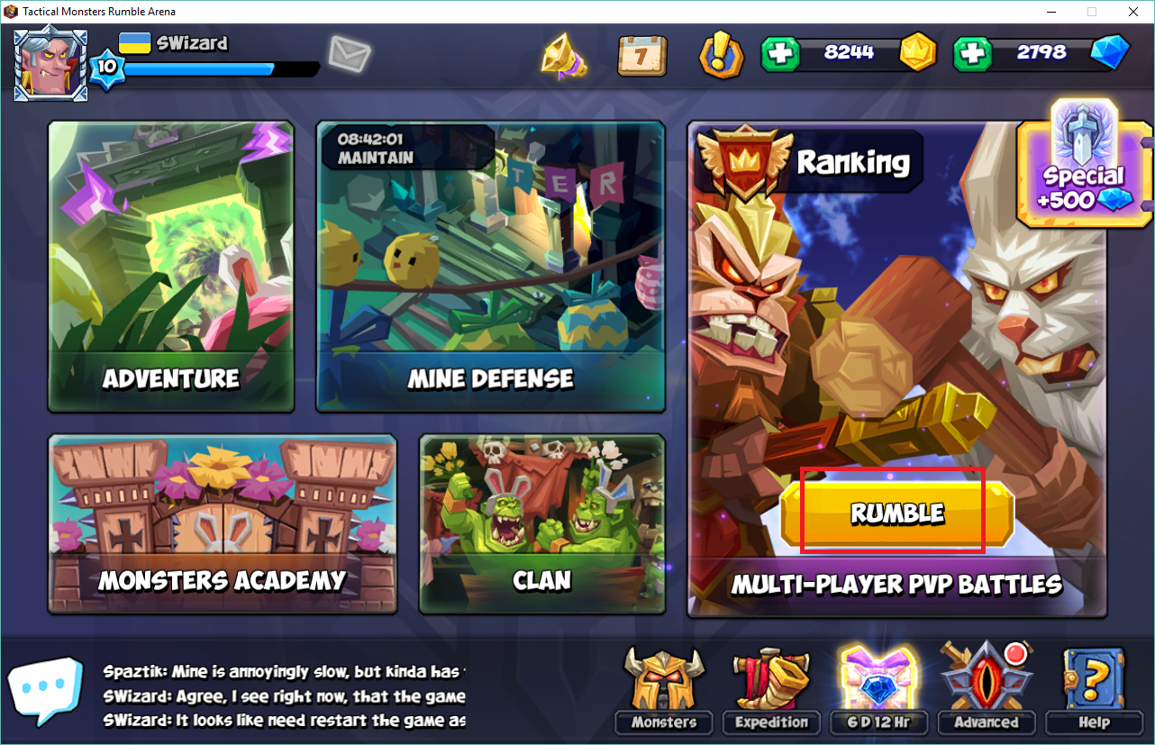

Next there are two options – the rumble will run or you see main screen. In first case please play one game manually to reach Rumble main page, see below.

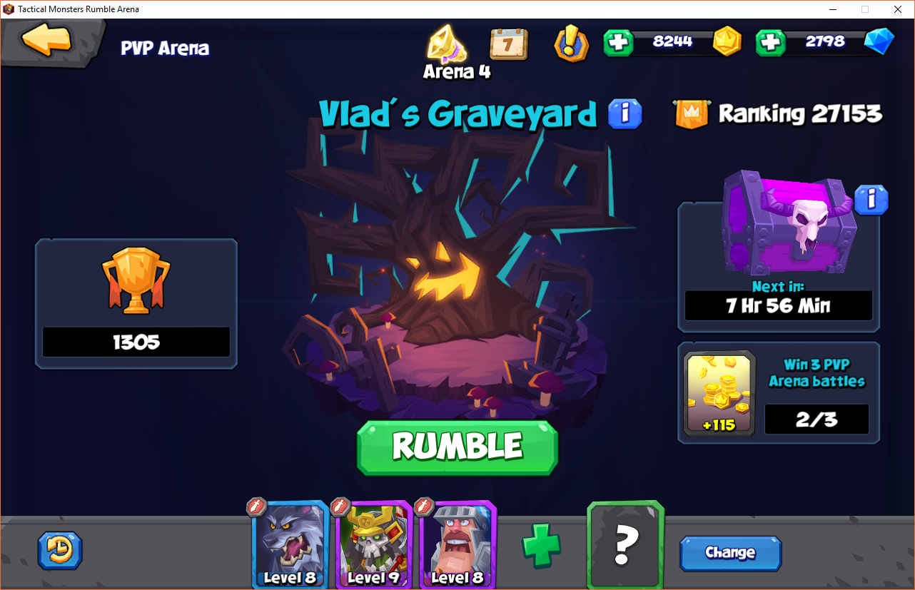

From this time you can run the Clicker by it “Run” button.

